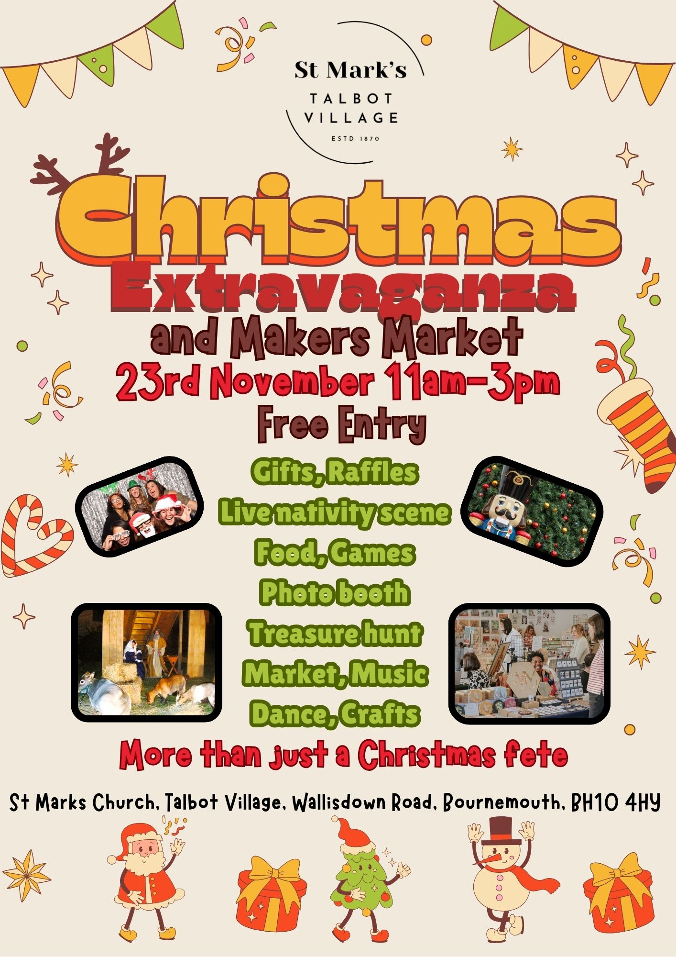

**LIVING NATIVITY SCENE**

**SATURDAY 14TH DECEMBER**

**AT 5.30PM-7.30PM**

**HOT CHOCOLATE AND MINCE PIES AVAILABLE**

**ST MARK’S CHURCH**

**WALLISDOWN ROAD, BOURNEMOUTH. BH10 4AE**

**www.stmarkschurch-talbotvillage.org.uk**